Authoring

Angelo Santos

Table of contents

# 1. Colors

* Red
* Green
* Blue

# 2. Shapes

* Square
* Circle
* Triangle

# 3. Textures

* Smooth
* Bumpy
* Fuzzy

# 4. Equations

Einstein’s theory of special relatively that expresses the equivalence of mass and energy:

$E=mc^{2}$

## 4.1 Bibliography

Knuth says always be literate [@canavire-bacarreza_unintended_2018].

1 + 1

2

## 4.2 References

# 5. Cross references

See Figure 1 in Section 5.1 for a demonstration of a simple plot.

See Equation 1 to better understand standard deviation.

## 5.1 Plot

import matplotlib.pyplot as plt  
plt.plot([1,23,2,4])  
plt.show()

|  |
| --- |
| Figure 1: Simple Plot |

## 5.2 Equation

$$s=\sqrt{\frac{1}{N−1}\sum_{i=1}^{N}{{\left(x_{i}−\overline{x}\right)}^{2}}} \left(1\right)$$

# 6. Callout

|  |
| --- |
| Note |
| Note that there are five types of callouts, including: note, tip, warning, caution, and important. |

|  |
| --- |
| Tip |
| Note that there are five types of callouts, including: note, tip, warning, caution, and important. |

|  |
| --- |
| Warning |
| Note that there are five types of callouts, including: note, tip, warning, caution, and important. |

|  |
| --- |
| Caution |
| Note that there are five types of callouts, including: note, tip, warning, caution, and important. |

|  |
| --- |
| Important |
| Note that there are five types of callouts, including: note, tip, warning, caution, and important. |

# 7. Article layout

## 7.1 Placing Colorbars

Colorbars indicate the quantitative extent of image data. Placing in a figure is non-trivial because room needs to be made for them. The simplest case is just attaching a colorbar to each axes:[1].

import matplotlib.pyplot as plt  
import numpy as np  
  
fig, axs = plt.subplots(2, 2)  
fig.set_size_inches(20, 8)  
cmaps = ['RdBu_r', 'viridis']  
for col in range(2):  
 for row in range(2):  
 ax = axs[row, col]  
 pcm = ax.pcolormesh(  
 np.random.random((20, 20)) * (col + 1),  
 cmap=cmaps[col]  
 )  
 fig.colorbar(pcm, ax=ax)  
plt.show()

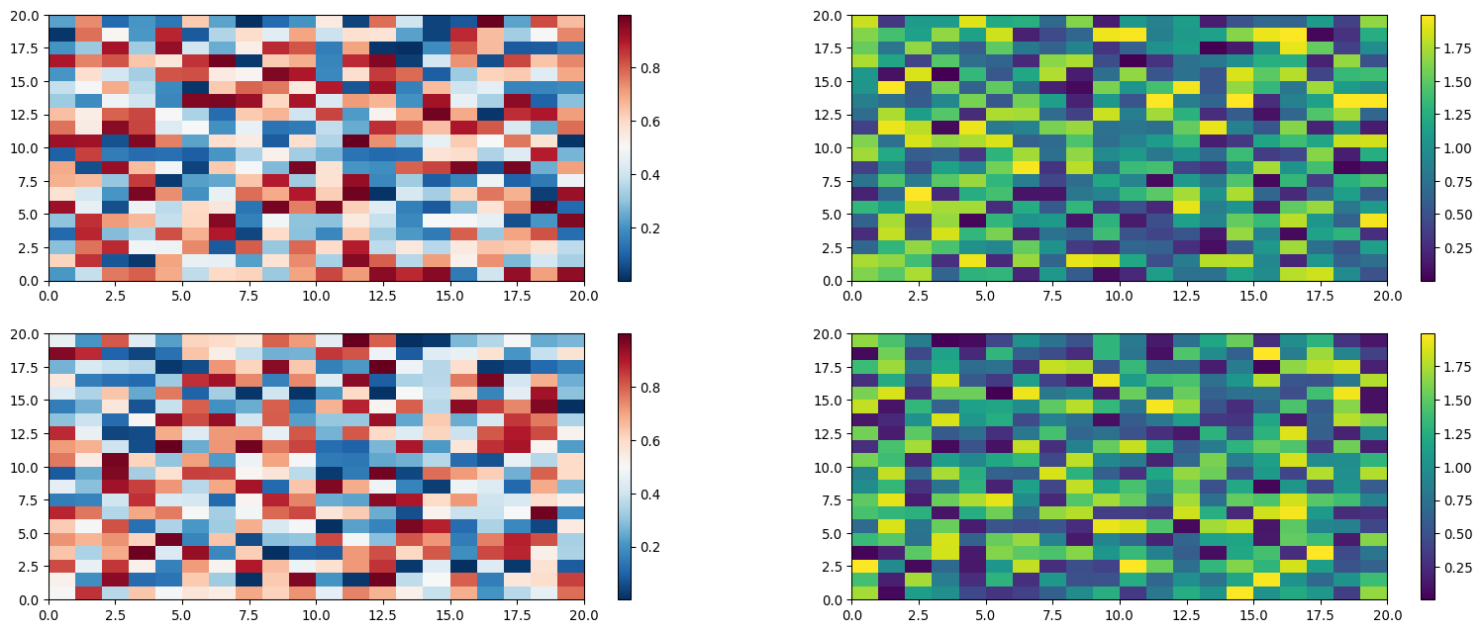

1. See the [Matplotlib Gallery](https://matplotlib.org/stable/gallery/subplots_axes_and_figures/colorbar_placement.html) to explore colorbars further